**Big Data for Newer Product of Tesla**

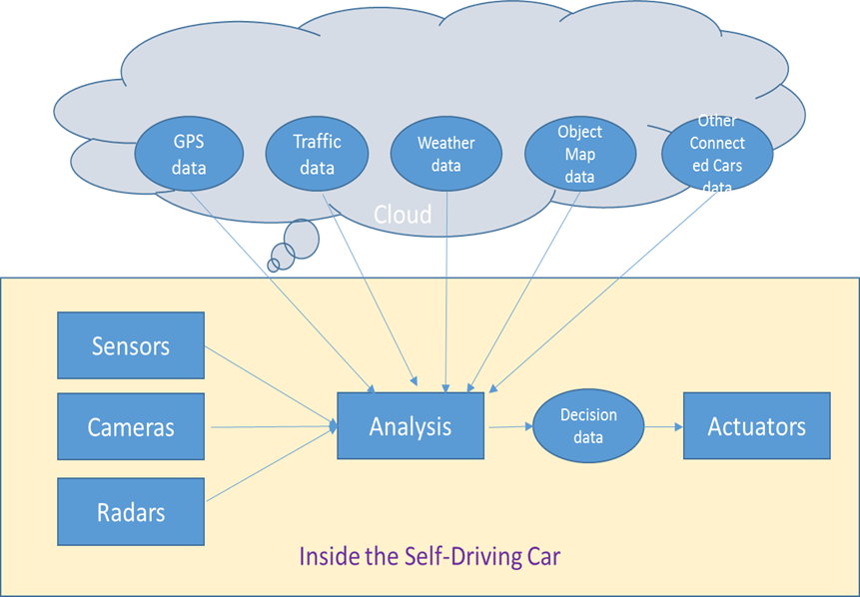

Tesla's most valuable asset is the massive amount of data it collects. This information is extremely useful since it can be used to analyze traffic patterns, create dynamic maps, and even track population flows over time.

This demonstrates that, while Tesla's core business is making and selling electric cars, their foresight in gathering this data, as well as their philosophy of using it to detect and fix issues and consumer needs, adds a significant value to their product. It may be regarded, in my opinion, one of Tesla's major benefits and one of the reasons for the brand's popularity.

The sheer quantity of their fleet is another advantage that contributes to this. This adds a lot of value to their data-driven strategy since their quickly expanding fleet (particularly with the release of the inexpensive Model 3, X and Y) allows them to collect more and more data to feed their algorithm as training data, which improves the accuracy of their models over time. Any other company attempting to enter this market would find it difficult to compete.

<https://digital.hbs.edu/platform-digit/submission/tesla-a-data-driven-future/>